Wix Quick Guide

For more help, visit https://support.wix.com/en/. If you have any questions, feel free to contact Brittany at bcook@destinationsenecacounty.org.

Quick Tips

- When editing, double click on the item you want to edit and a menu will pop up with information.
- To switch pages, either click the top icon on the left or the arrow on the page dropdown.

Using the Editor Menus
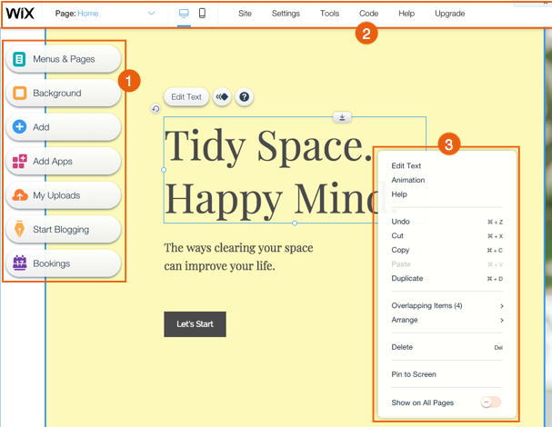
The Wix Editor is the platform you use to build your website. It is packed full of features to help your create a stunning and functional website.
There are 3 main menus inside the Editor:
﻿﻿The left menu
﻿﻿The top bar menu
﻿﻿The right-click menu

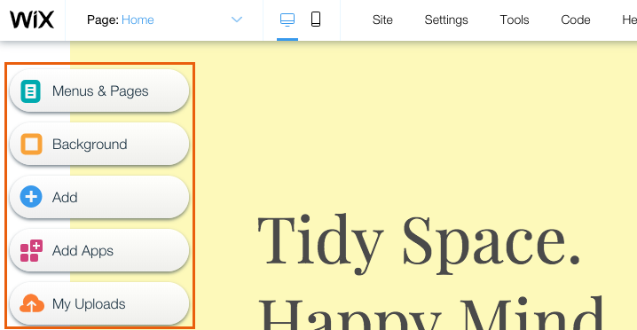
The Left Menu
The menu on the left side of the Editor contains all the features you need to build your site:
- Menus & Pages: From here you can add, delete and manage your site's pages.
- Background: Use this panel to set the background of your site's pages.
- Add: In this panel you will find tons of elements to add to your site. Use the tabs to navigate between the types of elements.
- Add Apps: Browse hundreds of apps in the Wix App Market and find the ones that suit your needs.
- My Uploads: Add media files to your Media Manager or purchase professional images and videos to use on your site.

The Top Bar Menu
The menu bar at the top of the Editor contains several tools and settings.
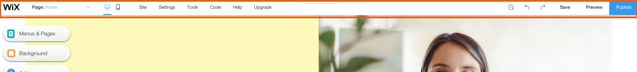
From left to right:
- Page drop-down: Navigate between your site's pages for editing.
- Desktop and Mobile Editors: Switch between the desktop and mobile Editors.
- Site: Save, preview and publish your site, get feedback or review your site history.
- Settings: Connect a domain, change your site's settings, set up a multilingual site and more.
- Tools: Show or hide the Editor Toolbar, Rulers, Gridlines and Snap to Object features.
- Corvid: Enable Corvid to start using Corvid by Wix.
- Help: Get immediate help inside the Editor. Click Editor Help Center to access thousands of help articles.
- Upgrade: Upgrade your site with a Premium Plan.
- Zoom Out & Reorder: Manage and reorder the sections on your page.
- Undo: Undo your last action (Ctrl + Z)
- Redo: Redo your last action (Ctrl + Y)
- Switch Editor Views: Switch between the desktop and mobile Editors.
- Save: Save your most recent changes.
- Preview: Preview your site.
- Publish: Publish your site and/or most recent changes.

The Right-Click Menu
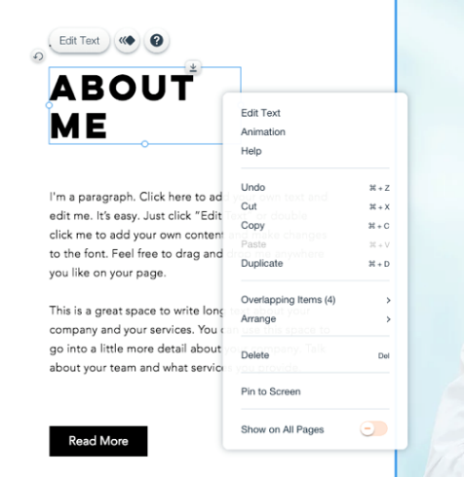
Right-click any element in the Editor to open the right-click menu which contains several options and action. Mac users should press control and click the mouse button.

The right-click menu includes features such as:​
- Copy and paste
- Show on all pages
- Copy design
- Undo and redo
- Arrange

Using the Editor Tools
There are several built-in tools in the Editor to make building your site a breeze!
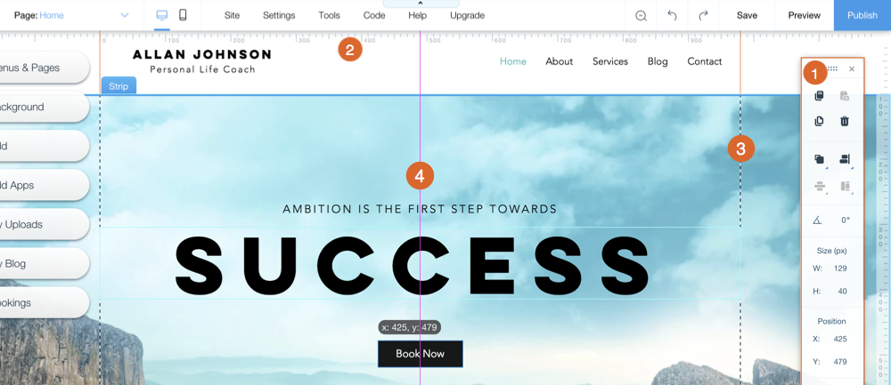
Learn how to use the:
﻿﻿ Editor Toolbar: The toolbar on the right side of the Editor.
﻿﻿ Rulers: The horizontal ruler on the top of your Editor, and the vertical one down the right side.
﻿﻿ Gridlines: The dotted lines that display your site boundaries.
﻿﻿ Snap to Objects: The automatic aligning tool that appears when you move elements.

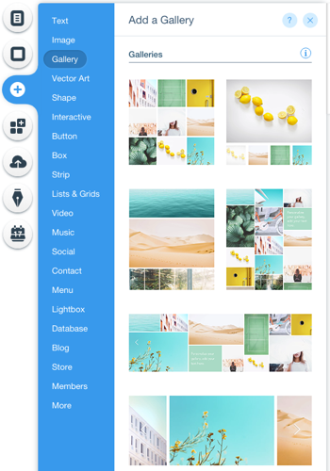
Adding Elements to Your Site
The Wix Editor contains hundreds of stunning, customizable elements that you can use to create your site. Choose from images, text, shapes, strips and more to make your site interesting and beautiful!

To add an element to your site:
- Click Add﻿﻿ on the left side of the Editor.
- Click a tab.
- Click an element or drag it to your site to add it.

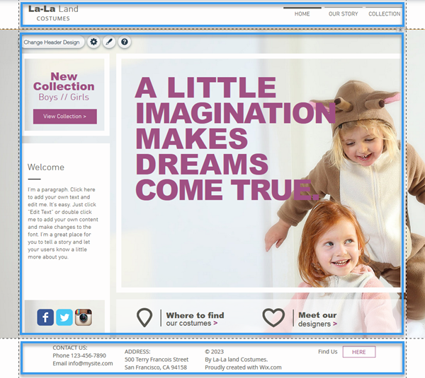
Arranging the Content on Your Site's Pages
Your site pages are divided into three sections, which are defined by the gridlines in the Editor:
- Header: Appears across the top of your site throughout all of your pages and usually contains your site menu and logo.
- Page Body: Contains the bulk of your page's content and differs from page to page.
- Footer: Appears across the bottom of your site throughout all of your site pages and usually contains your contact information, social icons and copyright information.

Icons in the Editor
When you click an element in your Editor, you may come across several icons.
Below are the icons that appear on elements and their uses:

Icon | Name | Action
 | Settings | Click to set up the element. The settings are different for each element.
 | Layouts | Click to change the layout of the element.  The layouts are different for each element.
 | Design | Click to design the element. The design options are different for each element.
 | Animate | Click to add animation to the element.
 | Link | Click to add a link to the element.
 | Show More | Click to show more options.
 | Crop & Edit | Click to make changes to your image.
 | Upgrade | Click to upgrade the element/feature.
 | Help | Click to learn more about the element or find an answer to a question your have.

